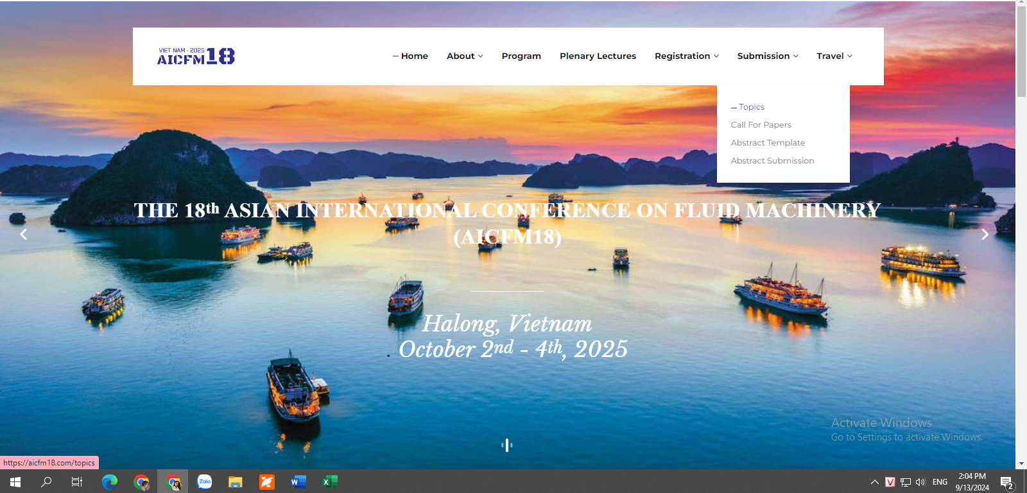

**Topic (bỏ)**

**Call for papers**

**Abstract-template**

**Abstract-submission**

**CREATE ACCOUNT**

|  |
| --- |
| Email |

|  |
| --- |
| Sign-up |

Already have an account? **Log In**

**Mail trả về:**

Tiêu đề: **AICFM18 - Sending Sign-in password**

Nội dung:

Congratulations on your successful registration for AICFM18

Login password: <… >

Login link:

**LOGIN TO CONTINUE**

Email:

|  |
| --- |
|  |

Password:

|  |
| --- |
|  |

|  |
| --- |
| Login |

**Abstract Submission**

Please complete the following details to submit your request.

(Authors are required to use the following template to prepare abstracts: **ABSTRACT TEMPLATE**)

**ABSTRACT INFORMATION**

**Topic*:**

Compressors

Pumps

Hydro Turbines

Fans and Blowers

Gas and Steam Turbines

Propellers

Wind Turbines

Jet Technology

Flow Meters and Valves

Fluid Systems

Renewable Energy

Propulsion

Tribology

Rotordynamics

Vibration and Noise

Seals and Bearings

Measurement Technology

Computational Fluid Dynamics

Cavitation & Multi-Phase Flows

Design, Optimization & Manufacturing

Control, Operation, Monitoring & Diagnosis

Microfluidics and Nanofluidics

**Abstract Title*:** *(Limited to 150 characters)*

|  |
| --- |
|  |

**SPEAKER INFORMATION**

**Title *:**

Prof. Dr. Mr. Mrs. Ms. Other. Please Specify:

**Full Name *:**

|  |
| --- |
|  |

**Institution(s)*:**

|  |
| --- |
|  |

**Email address*:**

|  |
| --- |
| **Tự động điền** |

**Phone number*:**

|  |
| --- |
|  |

**Abstract File*:**

*The abstract file must be a file of type: doc, docx*

|  |
| --- |
| **Click HERE to attach file** |

*Mail trả về: cc*[**aicfm18@hust.edu.vn**](mailto:aicfm18@hust.edu.vn), [**event4@hoabinh-group.com**](mailto:event4@hoabinh-group.com)

Dear <Title. Full Name>,

Your abstract, entitled **" <ABSTRACT TITLE> "** has been successfully submitted to The 18th Asian International Conference on Fluid Machinery (AICFM18). We also would like to take this chance to provide you with important details about the conference as follows:

Conference details:

•Date: **October 2nd - 4th, 2025**

•Location: **Vinpearl Resort and Spa Ha Long, Quang Ninh, Vietnam**

Important dates:

• Abstract Submission Deadline: **Extended to Feb. 20th, 2025**

• Early-Bird Registration: **Before September 20th, 2025**

• Notification of Abstract Acceptance: **March 20th, 2025**

• Full Paper Submission Deadline: **August 30th, 2025**

• Program Overview: **September 30th, 2025**

Please contact the Secretariat Team by sending an email to **aicfm18@hust.edu.vn** (cc: [**event4@hoabinh-group.com**](mailto:event4@hoabinh-group.com)) in case you want to edit the abstract or submission.

For further details please visit our website at [**https://aicfm18.com/**](https://aicfm18.com/)

We look forward to your participation and support.

Best Regards,

AICFM18 Secretariat Team

**Mail thông báo xác nhận bài:**

**Abstract Acceptance Notification**

Abstract ID#: [PaperID-001]

Category: [Autofills]

Dear [Presenting Author Name Autofills]:

Thank you for submitting your abstract for presentation at AICFM18, The 18th Asian International Conference on Fluid Machinery to be held October 2nd - 4th, 2025 at Vinpearl Resort and Spa Ha Long, Quang Ninh, Vietnam.

Your abstract has been accepted I have reviewed your poster abstract and found that it meets the preliminary acceptance requirements set by the Program Organizing Committee.

Congratulations, you can start planning your conference! Please save this message for reference.

**Presenter Registration**

Confirmation of your poster on the final programme is subject to the receipt by the Conference Organising Committee of your presenter registration by 30th August 2025 and full payment of all fees by 30th September 2025.

If you have extenuating circumstances that require payment later, please contact [aicfm18@hust.edu.vn](mailto:aicfm18@hust.edu.vn) (cc: [event4@hoabinh-group.com](mailto:event4@hoabinh-group.com)) by 15th September to make arrangements. Your presentation will be removed from the programme by 15th September if you have not registered and paid the full fee and have not contacted AICFM18 to make other arrangements. You must attend and present your poster at the conference to be included in the programme and proceedings.

The preliminary programme, including registration materials, will be posted online (<https://aicfm18.com/> ). Registration will open from February 1st. The Conference Organizing Committee's registration staff will provide confirmation when your application and fee have been received and processed.

Please note that AICFM18 does not have funding available to cover registration and/or travel costs for programme participants.

**Substitute Presenter**

Substitutes for presenters may be made up to September 15. Substitutes must be registered for the conference at the time of substitution, must be original co-authors, must not exceed the two sessions per person requirement, and will be listed as presenters in the conference materials.

Please contact **aicfm18@hust.edu.vn** (cc: **event4@hoabinh-group.com**) with the name of the presenting author; the name, email address, institution, country, and a short biography (maximum 30 words) of the substitute; and the abstract title and number. No other changes to your submission will be accepted after September 15.

**Click here to download the Poster template.**

**Click here to download the Power Point template.**

**Notification of presentation time**

You will receive final confirmation of your place in the program as well as the time, date and other information about the poster presentation between 1st and 30th September (subject to registration and payment by 15th September).

**Questions?**

Please contact **aicfm18@hust.edu.vn** (cc: **event4@hoabinh-group.com**) if you have any questions about your abstract submission or the session. Please reference your abstract number when contacting us.

This will help us respond to you as quickly and accurately as possible.

Thank you for your interest and we look forward to working with you to make this a successful conference.

Best Regards,

AICFM18 Secretariat Team